ENCRYPTING DATA

ENCRYPTING DATA
- The goal is to encrypt all data when saving to JSON and to decrypt it when the program boots

IMPORTS
- We'll need to import the hashlib library and the os library

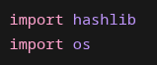

GLOBAL CONSTANTS
- Next we'll add global constants for JSON file path, salt size, and a master password

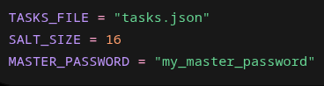

KEY CREATION FUNCTION
- We'll create a function that combines that master password and salt and hashes it for our key

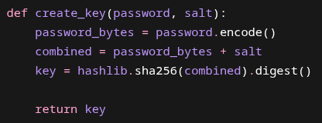

XOR FUNCTION
- Our XOR function will loop through our key indexes and XOR the bytes of our data and append them to a bytearray
- We'll return immutable bytes

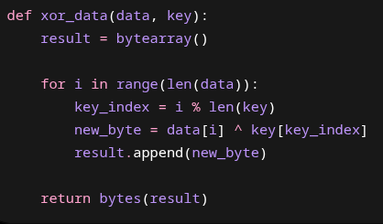

SAVE ENCRYPTED DATA FUNCTION
- We'll create a save_encrypted_data( ) function that takes data, filename, and password as parameters
- We'll create a JSON string and then encode it into bytes
- Generate our salt then create our key
- Encrypt our data with our xor_data( ) function, passing our JSON bytes and key as arguments
- We'll open our JSON file with "wb" write-bytes permission and write our salt + encrypted bytes

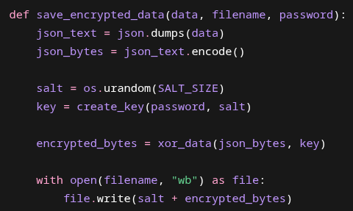

LOAD ENCRYPTED DATA FUNCTION
- We'll open our JSON file with "rb" read-bytes permission and load it into a variable
- We'll splice our salt and encrypted data
- We'll generate our key using our spliced salt and master password
- We'll decrypt our data with our XOR function – this will give us our JSON string bytes
- We'll decode our JSON string bytes into a JSON string and then turn our JSON string into Python-readable data with json.loads( )

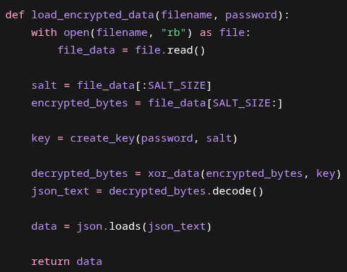

UPDATING SAVE_TASKS( ) FUNCTION
- We'll update our save_tasks( ) function to include our save_encrypted_data( ) function, also passing our data and global variables into our function
  - I'm not sure why we're passing our global variables, but we are

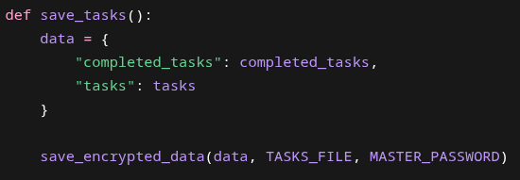

UPDATING LOAD_TASKS( ) FUNCTION
- We'll update our load_tasks( ) function by first calling the load_encrypted_data( ) function within in a try-except block
  - Because of this we'll have to include some other errors:
    - FileNotFoundError
      - This happens when Python tries to open a file that does not exist
    - UnicodeDecodeError
      - Python tries to turn bytes into readable text
      - But if something happens in the decrypt section, then the bytes may be random garbage
    - Json.JSONDecodeError
      - JSON expcets valid JSON text
      - If the decryption went wrong, then the text might be unreadable

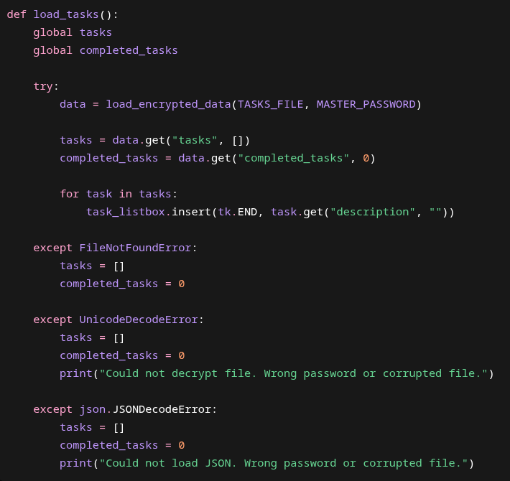

FULL CODE
import tkinter as tk
import json
import hashlib
import os
from tkinter import simpledialog
root = tk.Tk()
root.title("Task List")
root.geometry("500x450")
tasks = []
completed_tasks = 0
drag_start_index = None
TASKS_FILE = "tasks.json"
SALT_SIZE = 16
MASTER_PASSWORD = "generic_password"
def add_task_notes(description):
window = tk.Toplevel(root)
window.title("Task Details")
window.geometry("400x320")
window.transient(root)
window.grab_set()
window.focus_set()
tk.Label(window, text="Date:", font=("Arial", 12)).grid(row=0, column=0, sticky="e", padx=10, pady=8)
date_entry = tk.Entry(window, font=("Arial", 12))
date_entry.grid(row=0, column=1, padx=10, pady=8)
date_entry.focus_set()
tk.Label(window, text="Time:", font=("Arial", 12)).grid(row=1, column=0, sticky="e", padx=10, pady=8)
time_entry = tk.Entry(window, font=("Arial", 12))
time_entry.grid(row=1, column=1, padx=10, pady=8)
tk.Label(window, text="Notes:", font=("Arial", 12)).grid(row=2, column=0, sticky="ne", padx=10, pady=8)
notes_frame = tk.Frame(window)
notes_frame.grid(row=2, column=1, padx=10, pady=8)
notes_text = tk.Text(notes_frame, font=("Arial", 12), width=25, height=5)
notes_text.pack(side="left", fill="both", expand=True)
notes_scrollbar = tk.Scrollbar(notes_frame, command=notes_text.yview)
notes_scrollbar.pack(side="right", fill="y")
notes_text.config(yscrollcommand=notes_scrollbar.set)
def submit(event=None):
task = {
"description": description,
"date": date_entry.get(),
"time": time_entry.get(),
"notes": notes_text.get("1.0", tk.END).strip(),
"completed": False
}
tasks.append(task)
task_listbox.insert(tk.END, description)
save_tasks()
task_entry.delete(0, tk.END)
window.destroy()
submit_button = tk.Button(window, text="Create Task", font=("Arial", 12), command=submit)
submit_button.grid(row=3, column=1, pady=15)
window.bind("<Return>", submit)
def add_task(event=None):
description = task_entry.get()
if description == "":
return
add_task_notes(description)
def create_key(password, salt):
password_bytes = password.encode()
combined = password_bytes + salt
key = hashlib.sha256(combined).digest()
return key
def delete_task(event=None):
selected = task_listbox.curselection()
if selected == ():
return
index = selected[0]
task_listbox.delete(index)
tasks.pop(index)
save_tasks()
def drag_task(event):
global drag_start_index
new_index = task_listbox.nearest(event.y)
if drag_start_index is None:
return
if new_index == drag_start_index:
return
task = tasks.pop(drag_start_index)
tasks.insert(new_index, task)
refresh_listbox()
task_listbox.selection_set(new_index)
drag_start_index = new_index
def load_encrypted_data(filename, password):
with open(filename, "rb") as file:
file_data = file.read()
salt = file_data[:SALT_SIZE]
encrypted_bytes = file_data[SALT_SIZE:]
key = create_key(password, salt)
decrypted_bytes = xor_data(encrypted_bytes, key)
json_text = decrypted_bytes.decode()
data = json.loads(json_text)
return data
def load_tasks():
global tasks
global completed_tasks
try:
data = load_encrypted_data(TASKS_FILE, MASTER_PASSWORD)
tasks = data.get("tasks", [])
completed_tasks = data.get("completed_tasks", 0)
for task in tasks:
task_listbox.insert(tk.END, task.get("description", ""))
except FileNotFoundError:
tasks = []
completed_tasks = 0
except UnicodeDecodeError:
tasks = []
completed_tasks = 0
print("Could not decrypt file. Wrong password or corrupted file.")
except json.JSONDecodeError:
tasks = []
completed_tasks = 0
print("Could not load JSON. Wrong password or corrupted file.")
def mark_completed():
global completed_tasks
selected = task_listbox.curselection()
if selected == ():
return
index = selected[0]
task_listbox.delete(index)
tasks.pop(index)
completed_tasks += 1
save_tasks()
update_counter()
def open_task_notes(event=None):
selected = task_listbox.curselection()
if selected == ():
return
index = selected[0]
task = tasks[index]
window = tk.Toplevel(root)
window.title("Edit Task Notes")
window.geometry("430x360")
window.transient(root)
window.wait_visibility()
window.focus_set()
window.grab_set()
tk.Label(window, text="Task:", font=("Arial", 12)).grid(
row=0, column=0, sticky="e", padx=10, pady=8
)
description_entry = tk.Entry(window, font=("Arial", 12), width=28)
description_entry.grid(row=0, column=1, padx=10, pady=8)
description_entry.insert(0, task.get("description", ""))
tk.Label(window, text="Date:", font=("Arial", 12)).grid(
row=1, column=0, sticky="e", padx=10, pady=8
)
date_entry = tk.Entry(window, font=("Arial", 12), width=28)
date_entry.grid(row=1, column=1, padx=10, pady=8)
date_entry.insert(0, task.get("date", ""))
tk.Label(window, text="Time:", font=("Arial", 12)).grid(
row=2, column=0, sticky="e", padx=10, pady=8
)
time_entry = tk.Entry(window, font=("Arial", 12), width=28)
time_entry.grid(row=2, column=1, padx=10, pady=8)
time_entry.insert(0, task.get("time", ""))
tk.Label(window, text="Notes:", font=("Arial", 12)).grid(
row=3, column=0, sticky="ne", padx=10, pady=8
)
notes_frame = tk.Frame(window)
notes_frame.grid(row=3, column=1, padx=10, pady=8)
notes_text = tk.Text(notes_frame, font=("Arial", 12), width=25, height=6)
notes_text.pack(side="left", fill="both", expand=True)
notes_scrollbar = tk.Scrollbar(notes_frame, command=notes_text.yview)
notes_scrollbar.pack(side="right", fill="y")
notes_text.config(yscrollcommand=notes_scrollbar.set)
notes_text.insert("1.0", task.get("notes", ""))
def save_changes(event=None):
task["description"] = description_entry.get()
task["date"] = date_entry.get()
task["time"] = time_entry.get()
task["notes"] = notes_text.get("1.0", tk.END).strip()
refresh_listbox()
task_listbox.selection_set(index)
save_tasks()
window.destroy()
save_button = tk.Button(
window,
text="Save Changes",
font=("Arial", 12),
command=save_changes
)
save_button.grid(row=4, column=1, pady=15)
window.bind("<Return>", save_changes)
def refresh_listbox():
task_listbox.delete(0, tk.END)
for task in tasks:
task_listbox.insert(tk.END, task["description"])
def save_encrypted_data(data, filename, password):
json_text = json.dumps(data)
json_bytes = json_text.encode()
salt = os.urandom(SALT_SIZE)
key = create_key(password, salt)
encrypted_bytes = xor_data(json_bytes, key)
with open(filename, "wb") as file:
file.write(salt + encrypted_bytes)
def save_tasks():
data = {
"completed_tasks": completed_tasks,
"tasks": tasks
}
save_encrypted_data(data, TASKS_FILE, MASTER_PASSWORD)
def start_drag(event):
global drag_start_index
drag_start_index = task_listbox.nearest(event.y)
def stop_drag(event):
save_tasks()
def update_counter():
counter_label.config(text=f"Tasks Completed: {completed_tasks}")
def update_counter_manual():
global completed_tasks
new_total = simpledialog.askinteger(
"Update Completed Tasks",
"Enter the number you want the running total to be:",
parent=root
)
if new_total is None:
return
completed_tasks = new_total
save_tasks()
update_counter()
def xor_data(data, key):
result = bytearray()
for i in range(len(data)):
key_index = i % len(key)
new_byte = data[i] ^ key[key_index]
result.append(new_byte)
return bytes(result)
task_listbox = tk.Listbox(root, font=("Arial", 14), width=40, height=10)
task_listbox.pack(pady=10)
task_listbox.bind("<Button-1>", start_drag)
task_listbox.bind("<B1-Motion>", drag_task)
task_listbox.bind("<ButtonRelease-1>", stop_drag)
task_listbox.bind("<Double-Button-1>", open_task_notes)
load_tasks()
task_entry = tk.Entry(root, font=("Arial", 14))
task_entry.bind("<Return>", add_task)
task_entry.pack(pady=10)
task_entry.focus_set()
button_frame = tk.Frame(root)
button_frame.pack(pady=5, fill="x", padx=40)
delete_button = tk.Button(button_frame, text="Delete Task", font=("Arial", 12), command=delete_task)
delete_button.pack(side="left", padx=5)
add_button = tk.Button(button_frame, text="Add Task", font=("Arial", 12), command=add_task)
add_button.pack(side="left", padx=5)
mark_button = tk.Button(button_frame, text="Mark Completed", font=("Arial", 12), command=mark_completed)
mark_button.pack(side="left", padx=10)
counter_frame = tk.Frame(root)
counter_frame.pack(pady=10)
counter_label = tk.Label(counter_frame, text=f"Tasks Completed: {completed_tasks}", font=("Arial", 14))
counter_label.pack(side="left", padx=5)
update_counter_button = tk.Button(counter_frame, text="Update", font=("Arial", 12), command=update_counter_manual)
update_counter_button.pack(side="left", padx=5)
root.bind("d", delete_task)
root.mainloop()

